**TPO48 L2 Origin of Volcanoes列强瓜分单词表**

**1. Before Listening**

|  |  |  |  |
| --- | --- | --- | --- |
| The crust | 地壳 | tectonic plates | 板块 |
| slab | 平板，厚板 | slide | 滑行 |
| molten rock, steel, lava (vs. larva) | 熔岩/岩浆 | boundaries | 边界 |
| squeezing up | 挤压 | continental or oceanic plate | 大陆或海洋板块 |
| magma | 岩浆 | Anomaly/ anomalousness | n. 异常的人或物; 不规则  adj. 反常的; 不规则的 |
| geophysicist | 地球地质物理学家 | Come up with | 提出，想出 |
| Propose a theory | 提出一个新理论 | plume | 岩柱Plume oneself on |
| columns | 支柱，岩柱  专栏 | Geology An upwelling of molten material from the earth's mantle. | 【地质学】 地柱：从地幔隆起的一段熔化物 |
| Well V. | 喷出，涌出 | interior | adj. 内的, 内侧的 |
| dormant  active | adj.休眠的 | Incidentally, | By the way 顺带一说 |
| extinct | 灭绝 | topographic  topography /təˈpɔgrəfɪ/ | 地形上的; 地志的; 地形测量的 |
| seismographic | 测震学，地震仪的 | geochemical | 地球化学的 |
| Be consistent with | 一致，符合，与...一致 | Definitive (≠ tentative)  ！＝ | 最终的 决定性的  adj. 试验性质的  tentative 试探性的（不确定的uncertain） |
| Proponent (≠opponent) | 支持者 | sequence | v./n. 排序 测定 |
|  | |  | |

**补充：**

更不用说：much less ；let alone；not to speak of

TOEFL listening is already challenging/demanding/tough/arduous, much less the lectures in universities.

not···but 不是而是

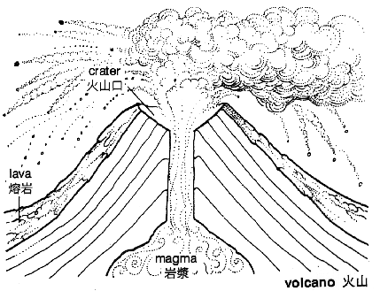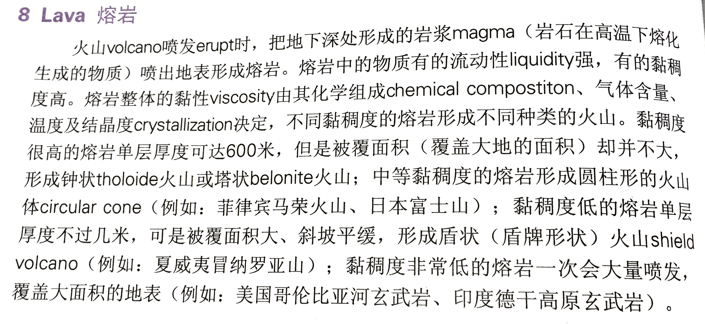

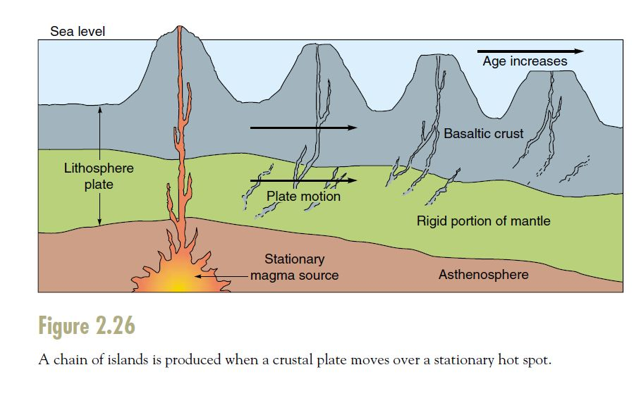

**asthenosphere**  软流层 [地质] 软流圈 [地质]

**lithosphere**   n.岩圈, 地壳

**2. While Listening**

**2.1Take Notes on your notebook**

**2.2 Questions**

**1. What is the lecture mainly about?**

A. Ways to determine the ages of volcanic islands

B. Criteria for classifying various types of volcanoes

C. Explanations for why volcanoes occur in some locations

D. Methods for measuring magma produced by volcanoes

**2. According to the professor, why was the hot spot theory originally proposed?**

A. To explain prolonged volcanic activity far from plate boundaries

B. To explain why volcanoes form both on land and in the ocean

C. To explain variations in the amounts of magma produced by volcanoes

D. To explain why volcanoes may become inactive after millions of years

**3. Why does the professor describe moving a sheet of heavy paper over a candle?**

A. To clarify that plumes do not produce great amounts of heat

B. To describe an experiment he would like the students to conduct

C. To illustrate one hypothesis for the way some volcanic anomalies are formed

D. To emphasize the thinness of some of Earth’s tectonic plates

**4. Why does the professor discuss how high one of the Hawaiian Islands rises above the**

**ocean floor?**

A. To provide evidence supporting the plume hypothesis

B. To compare the Hawaiian Island to other volcanic islands in the Pacific Ocean

C. To point out a common difference between volcanic mountains and other types of mountains

D. To emphasize that hotspot volcanoes can produce large amounts of magma

**5. According to the crack hypothesis, what causes a hot spot?**

A. Hot magma rises from deep in Earth to melt a piece of the crust.

B. Hot magma flows out through a break in the side of an active volcano.

C. Hot magma flows up through spaces created between tectonic plates as they move.

D. Hot magma flows up at a point where a tectonic plate has been stretched thin.

**6. What is the professor’s opinion of the two main hypotheses he presents?**

A. **Neither** hypothesis can explain the formation of the Hawaiian Islands.

B. Each hypothesis accounts for some, but not all volcanic anomalies.

C. Each hypothesis explains the formation of more volcanoes than plate tectonics does.

D. The studies supporting the crack hypothesis are more convincing than those supporting the

plume hypothesis.

**2.3 Detailed Question**

1) Where do most volcanoes occur?

On the edges of slabs

2) Why does the professor mention the Hawaii islands?

These volcanos are in the center of slabs, which is almost impossible to generate volcanos.

3) What is the first theory to explain the Hawaii islands?

The plume theory.

4) How does it give explanations?

A burning candle, which burns tiny spots on a paper.

5) Why does the professor mention plume theory?

6) The distance between the curst and the plume decides the _________ of volcanoes.

7) How does the professor organize his lecture? (some choices may be used more than once)

A. usual phenomenon B. example of anomaly C. one possible theory D. explanation of the theory

E. another possible theory F. assessment of the theory

**2.4 Script Dictation**

**Listen to part of a lecture in an art history class.**

Listen to part of the lecture in an Earth Science class.

The class has been discussing volcanoes.

Okay. We know the Earth's surface, the crust, is made up of____________________, and these huge ______________________ are slowly sliding over or under or past each other, and we said that most of the world's volcanoes occur _____________________of these tectonic plates where you have________________________ through gaps between the plates.

**But** some volcanoes occur _________________, but in the ________________ a continental or oceanic plate. The Hawaiian Islands**, for example,** are __________________________from any plate boundary, and yet you have vast amounts of ________________, ________________, flowing up through the earth's crust, which means, of course, that volcanic activity there can't be explained simply by plate tectonics. **So,** how do we __________ ________________, these _________________the general rule?

**Well,** back in 1963, a geophysicist by the name of _______ came up with a _________________________________ this particular type of volcanic activity can occur, and can go on for maybe ______________________________________.Wilson's theory was that: hot spots exist ___________________, and they're _________________ of these volcanoes.

**But** what causes the hot spots? **Hmm, well,** the most popular theory that's been proposed is the ______________. According to this hypothesis, plumes, uh, basically columns of extremely hot magma. These plumes well up ______________________________ the planet's interior, maybe even as _______ as its _____,and rise all the way up to ______________ the Earth's _________. Imagine a______________, and imagine moving _______________________ slowly over the flame of the candle. You're gonna get a series of burned spots in the paper, **well,** that's just like what's happening with the Hawaiian Islands, but instead of a sheet of paper, you've got a tectonic plate, and it's moving over this _______________________, and rather than a series of burned spots in the paper, you're getting a chain of ____________________ where the _____________melts through the crust under the Pacific Ocean at one point after another with active volcanoes on ________________that are now just ___________________, and the other islands, well, the _________________ from the plume they are now,________________ they are, and __________________ their volcanoes went ______________________.

Incidentally, volcanic islands may seem small, but the island known as the Big Island Hawaii is one of the _________________________ on the planet, more than ______________________ from the sea floor to the ocean surface, and almost that much again, up to its highest peak. That's nearly _____________________ from ___________to the _____________ on the island, **which** makes it taller even than Mount Everest. 埃佛勒斯峰（喜马拉雅山主峰之一，中国称珠穆朗玛峰）

**So,** you can imagine the huge amounts of_______, or __________, that've flowed up to form even just this one island, much less the whole chain of islands. **Now,** the Plume Hypothesis provides a pretty elegant explanation for a volcanic anomaly, like the Hawaiian Islands. **But, while** it's hypothetically attractive,

there's ____________________ to support the theory, because so far, no one's been able to actually ___________________________________________. Some studies have been done, seismographic, geochemical, where the data's ________________ the model, **but** they aren't ________________. Even the model supporters are __________________________ that it explains ________________. (注意汉英副词位置的不同。) And like any popular theory, I suppose, it has some _________________. These critics have **put forth** a number of ______________, all ____________ so far.

**But** one well-regarded theory is _________________,4 .which assumes that hot spots are ___________ when a piece of_________ gets ____________________________and the resulting stress __________________ to open up _____________ in the crust, and it's through these cracks that magma _________________ to form volcanoes.

Proponents of the crack hypothesis consider this a _____________________ and believe that magma's ____coming up from ________________ the Earth's interior, **but rather** from______________ the surface crust. This hypothesis is attractive, because it___________ what we already know about plate tectonics and it fits what we know about _________________________, **but** how well does it explain the Hawaiian Islands？

Could a series of random cracks produce that same particular_______________ that's sequenced so neatly from old to young?

You know, it ________________me when a theory depends on _______________ to produce results.

**2.5 general structure of the lecture**

**Topic: How to explain some volcanic anomalies ？**

**1) introduction of the topic: normally volcanoes** occur_______________________, but Hawaii, _____________________, also has ____________________________.

**2) One possible theory:** ________________________.

The hotspot is explained by ________________________, which is _______________________.

The volcanoes are caused just as holding a __________________________ above ________________.

So do the Hawaii islands. It is _________ from sea floor to ocean surface and ______from sea floor to its highest peak.

The problem of this theory is that ________________________________.

**3) Another possible theory:** _______________________

It says that the magma pushes up to form volcanoes because _________________________________.

It believes that magma does not come from _____________________, but from ____________________.

The merits of this theory is that ___________________________________

The problem of this theory is that _____________________________________________.

**4) Attitudes of the professor:**  ________________________________

**3. After Listening**

**Make a summary of the lecture**

**Correction**

|  |  |  |
| --- | --- | --- |
| **SN** | **Types of Questions** | **Analysis** |
| **1** |  |  |
| **2** |  |  |